Overview: Create a form for the user to enter two numbers and one button to calculate the sum. When the user clicks on the button we should call a function that calculates and prints the sum in the document.

Steps:

1. Open template.html in the editor of your choice.
2. Save As Lab6.html
3. In the body, create the following form:

<form>

Number 1: <input type="text" id="num1" /><br />

Number 2: <input type="text" id="num2" /><br />

<input type="submit" value="Add Numbers" onclick="addNumbers(num1.value, num2.value)" />

<br />

</form>

1. In the head section type the following script. Do not copy and paste!

<script>

function addNumbers(x,y) {

var sum = x + y;

document.write (sum);

}

</script>

1. Save lab6.html
2. Open Lab6.html in the browser of your choice. This lab will use Chrome, so the development tools in your browser may be a little different. You will need to research.
3. Press F12 to open the developer tools.
4. Be sure to select “Sources” and then click on the lab6.html. 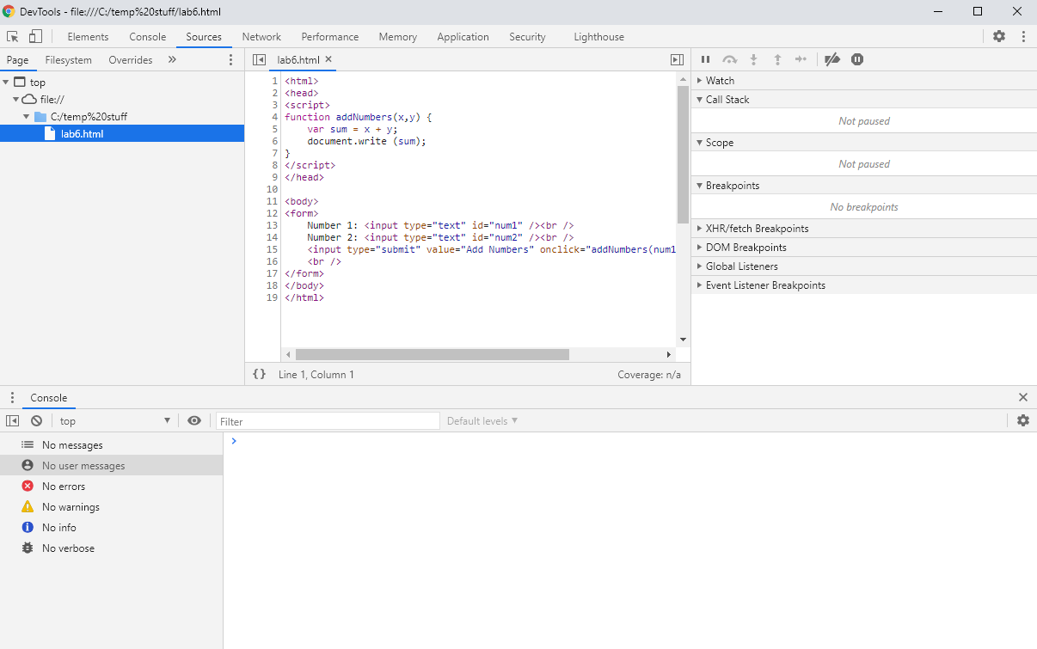
5. On the line that has “var sum = x + y;”, click to the left of the line number to set a break point.



1. In your web browser, enter two values and click on the Add Numbers button. You should be debugging your code now!

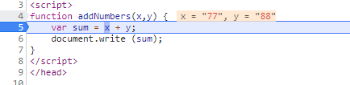

1. Press F11 to step through your code and note the results.